**Sequence Diagram:**

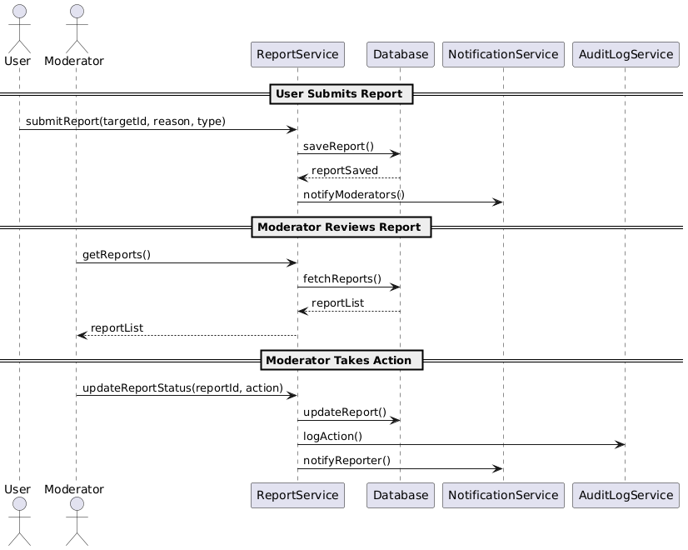

**State Diagram**

**Class Diagram**

**ERD**

**Functional Requirements**

1. Users can report posts, comments, or users for violating community guidelines.
2. Admins and moderators can view, filter, and manage reports.
3. System must notify moderators when a new report is submitted.
4. Each report must be tagged with type, reporter, timestamp, and description.
5. Moderators can change report status: Pending, Reviewed, Action Taken, Dismissed.
6. Actions can include post removal, user warning, or account suspension.
7. System logs actions taken on reports.
8. Reports can be exported by admin.

**Non-Functional Requirements**

|  |
| --- |
| 1. Reports must be stored securely and retrievable within 1 second. 2. Only authorized moderators/admins can view or manage reports. 3. Real-time updates should be sent via websockets or polling. 4. Reports and their statuses must be audit-logged for transparency. 5. The system should handle a minimum of 1,000 reports per day. |
|  |

|  |
| --- |
|  |